## **Season 1**

### Execution Context

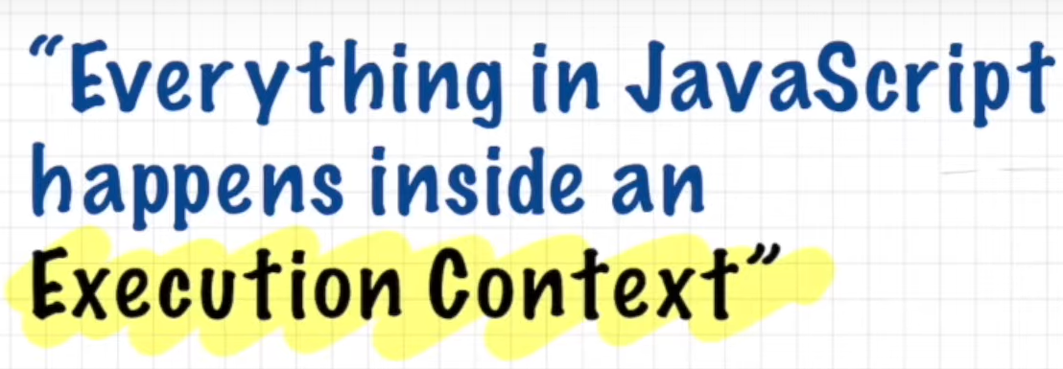

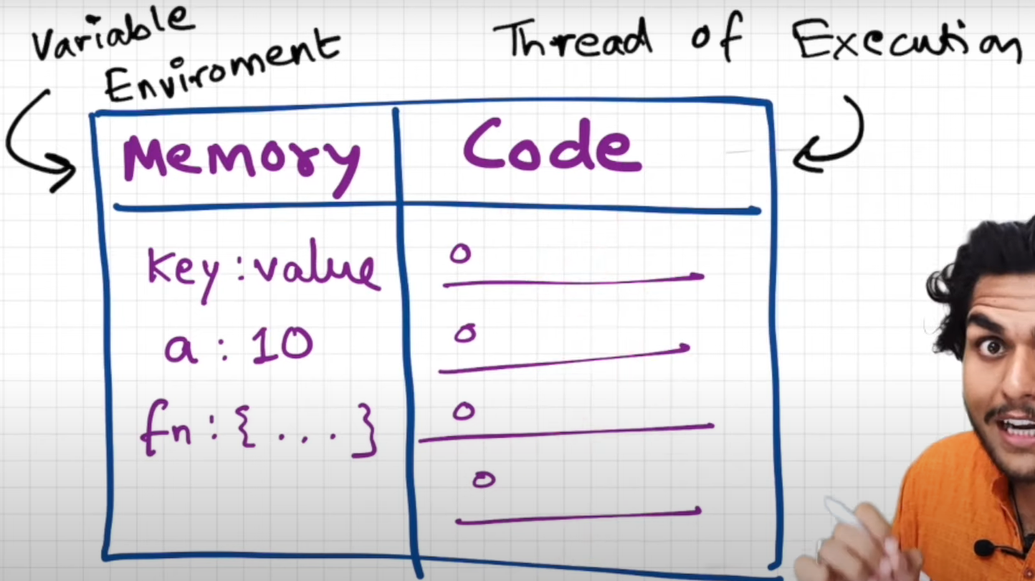

Memory component is where variables and functions are saved as key value pairs and code component is the palace where whole javascript code is executed

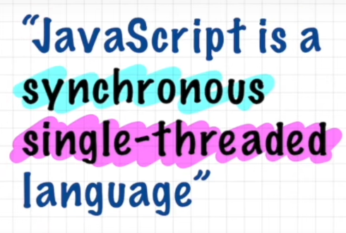

Single threaded - javascript can execute single command at a time

Synchronous - js can execute code only one command in a specific order. It will go to next line when current line is finished execution

**Phase 1: Javascript engine goes through the entire code and allotted memory for variables and functions. For variables special value ‘undefined’ will get stored.for functions entire code will be stored and undefined value for the variables inside function**

**Phase 2 : execute the code line by line. In this step n = 2 function invocation function name () - square( ). For functions new execution context will be created**

## 

For functions, new memory context will be created

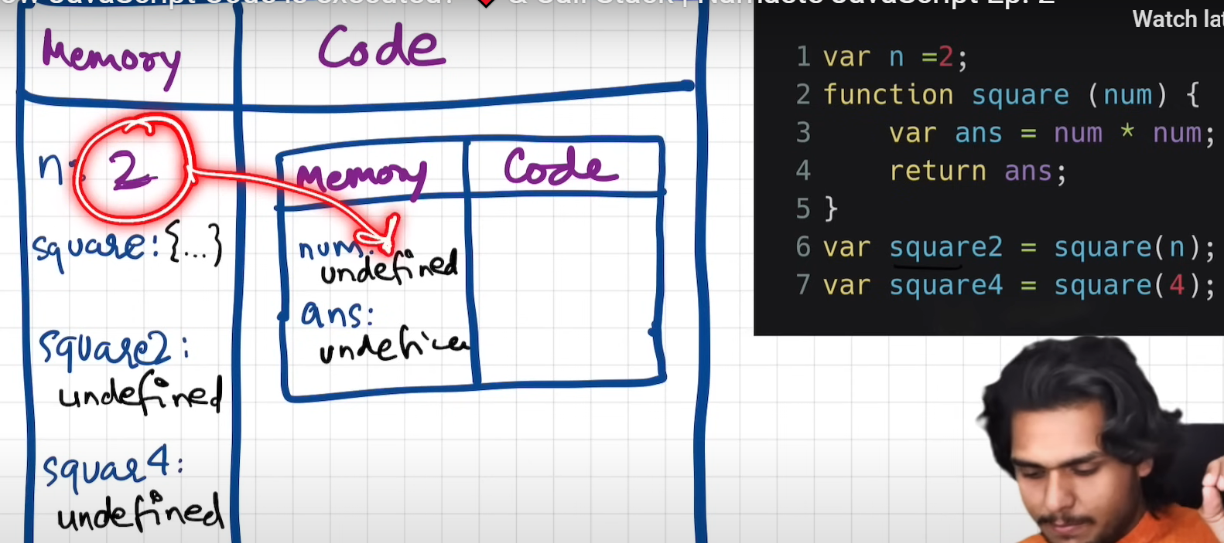

After the function execution once it completed the execution context will be deleted automatically

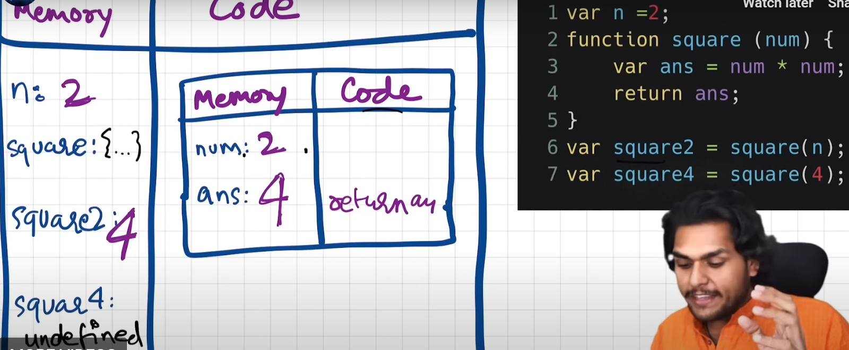

Once the entire code gets executed, Entire global context will be deleted

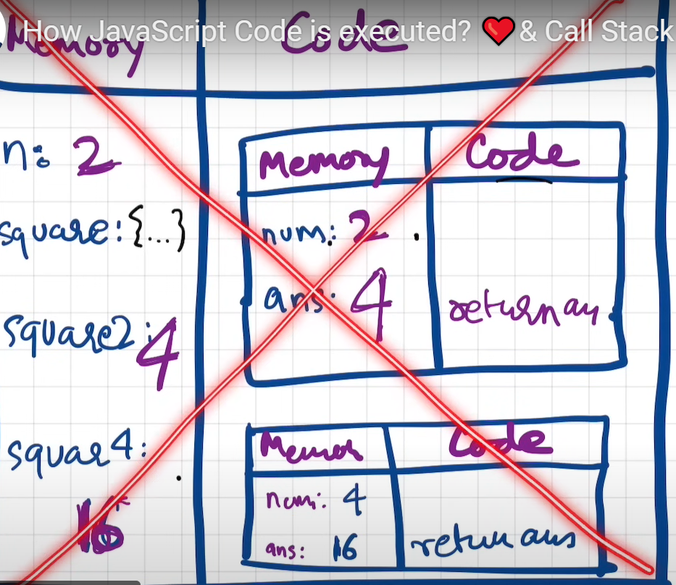

### Call Stack

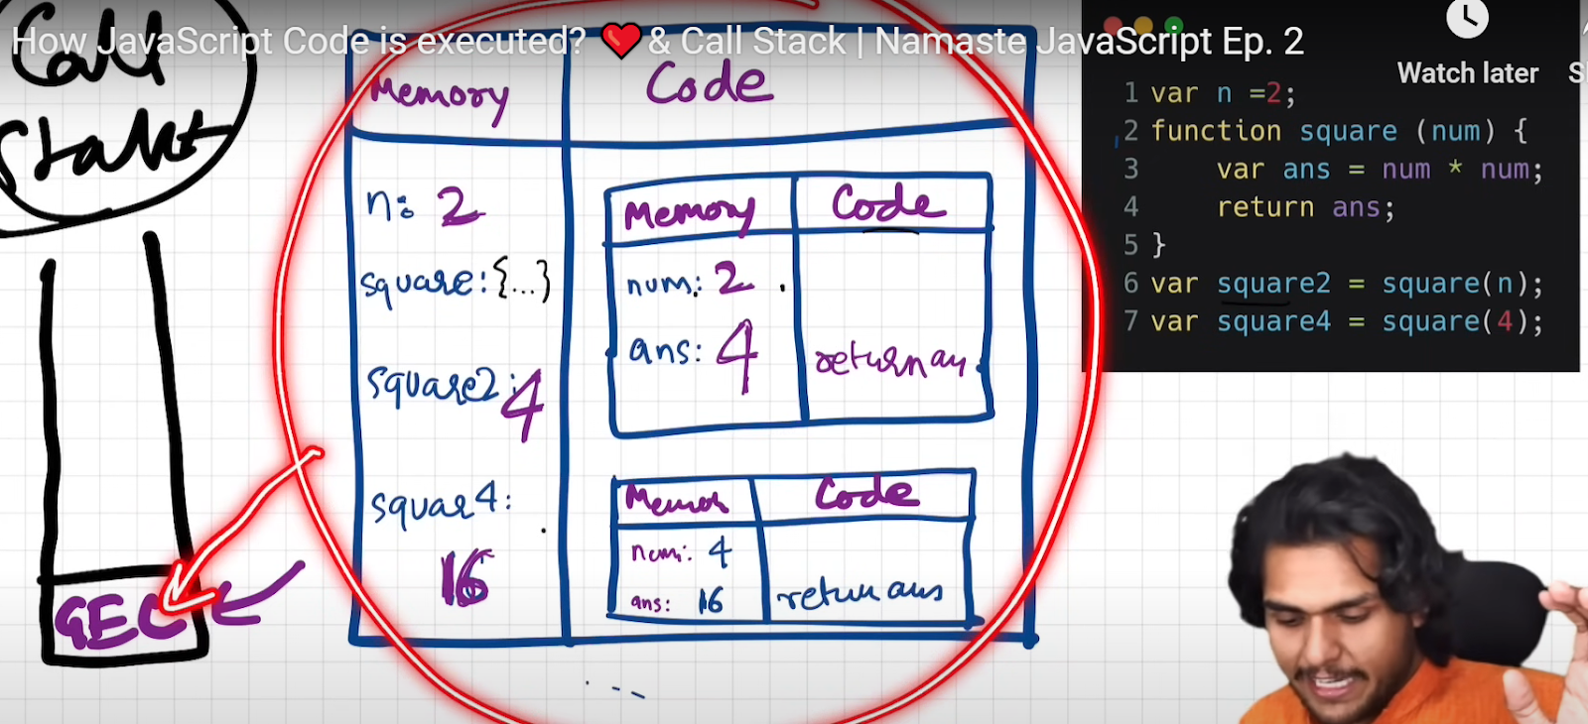

**In call stack, GEC global execution context will get created as a first step. Then E1 execution context for function square(n) will go next to the call stack. After it E1 got executed it will popped out from stack and the control moved to GEC where it left for example to line# 6 here**

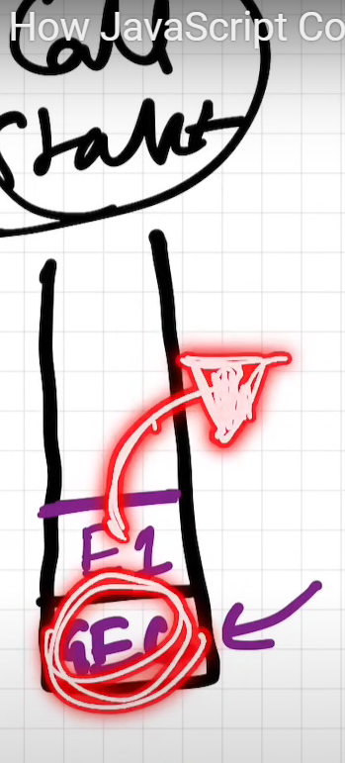**entire execution context creation and deletion is managed by callstack in javascript**

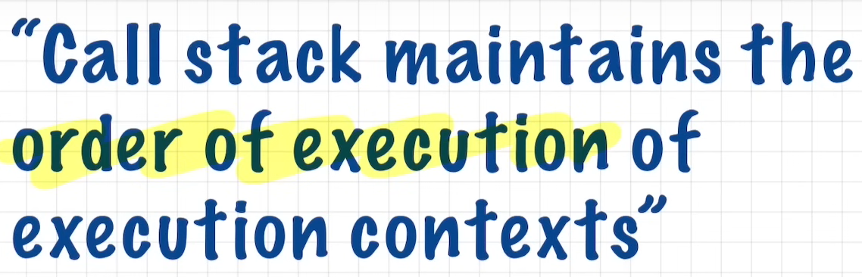

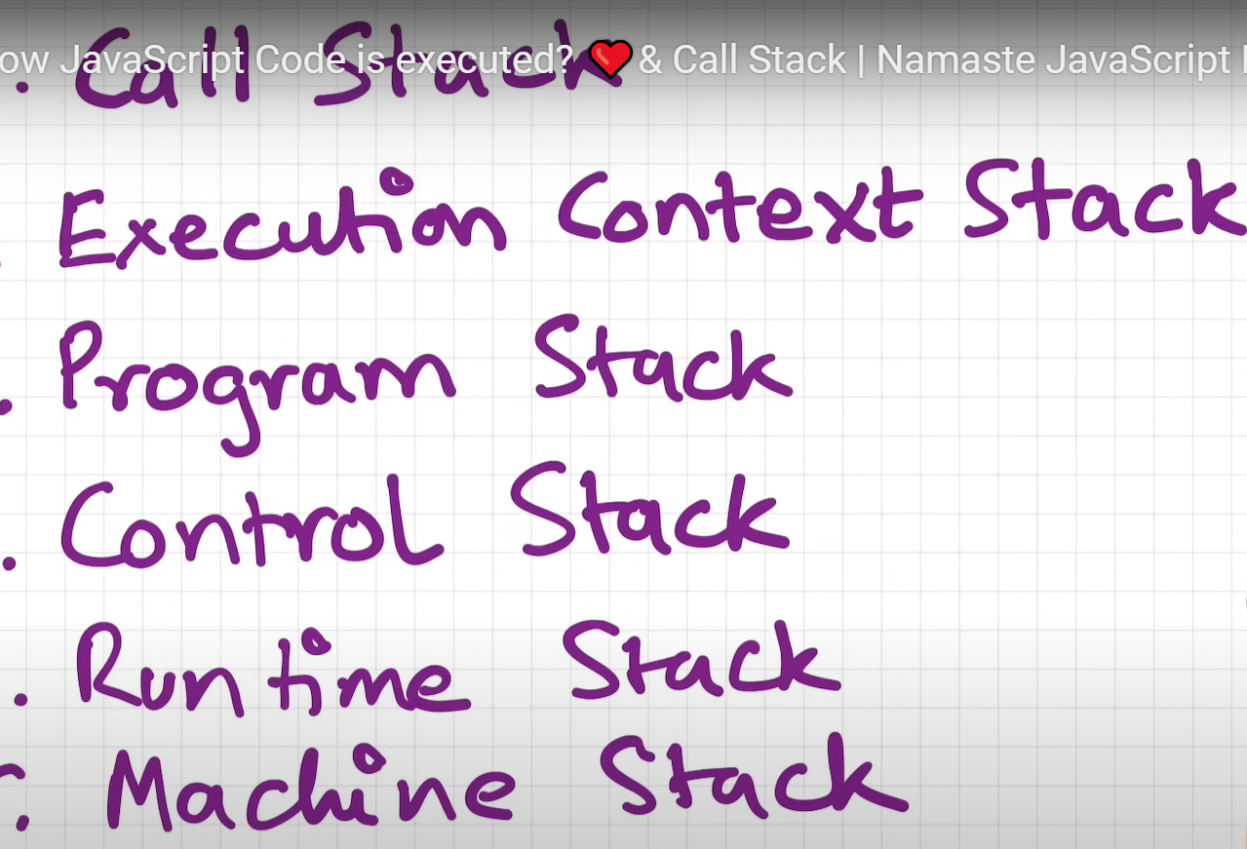

### Shortest Javascript Program

Shortest Javascript program is just an empty file

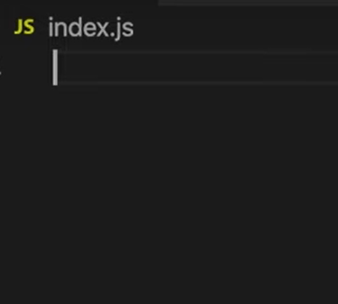

**Debugger in an empty file - global execution context is created**

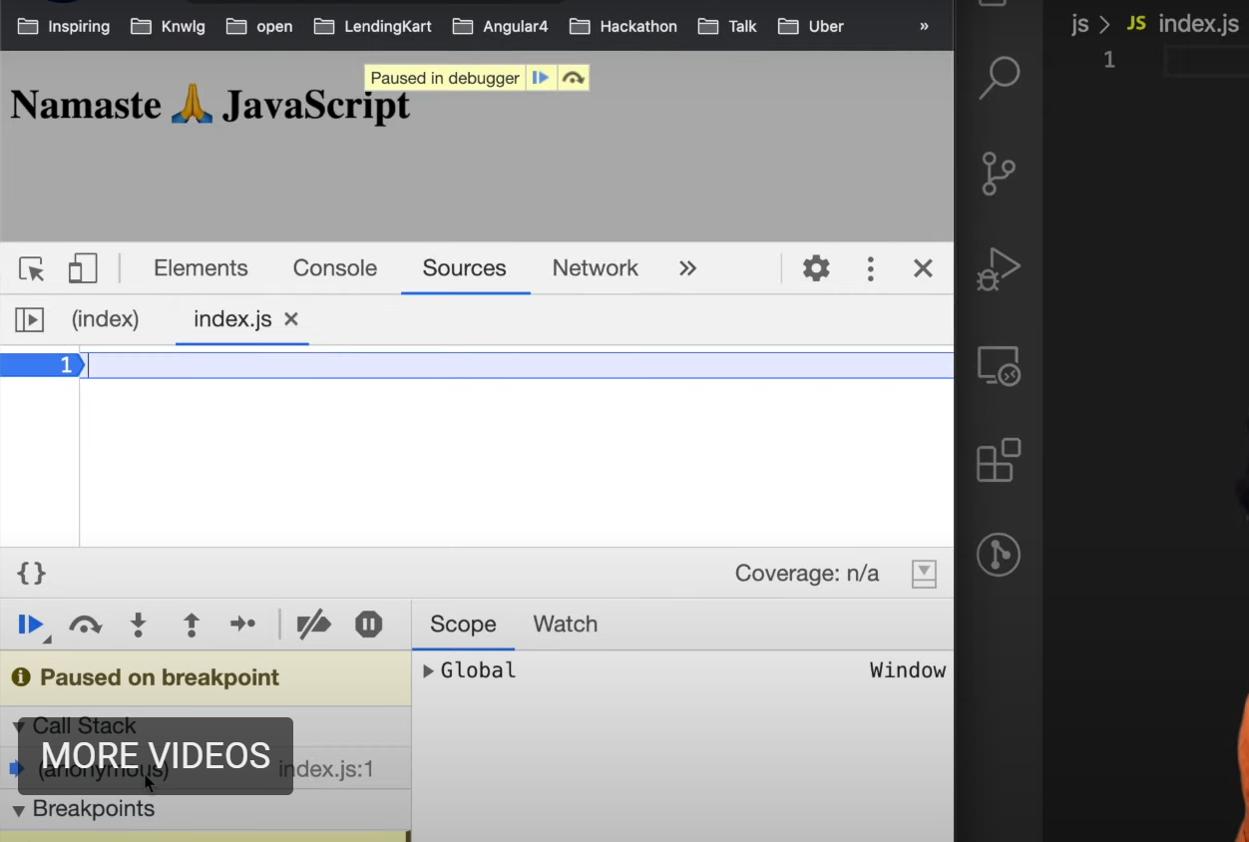

**Javascript engine will create a window. You can see it in console**

We didn’t put window inside our code. JS engine creates on its own

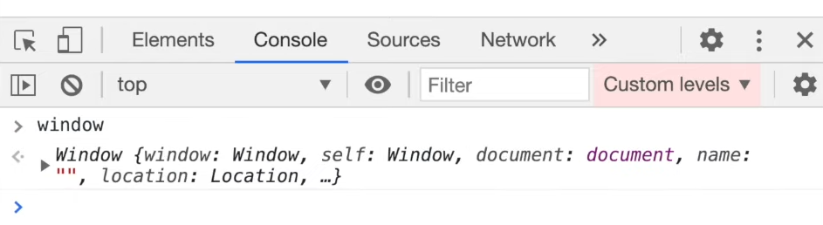

**The variables and functions are created by JS engine and put in the global execution context**

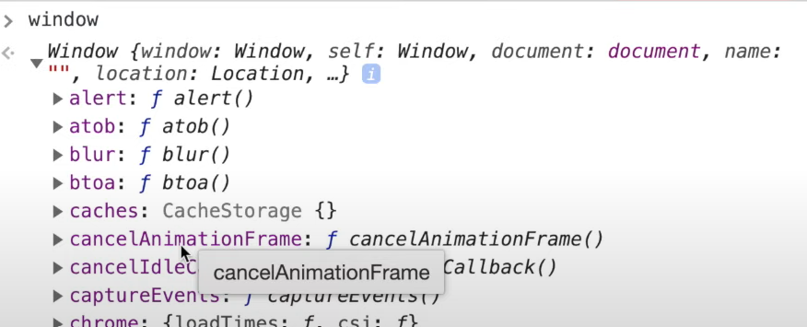

**JS engine will also create ‘this’ keyword**

